# Manufacturing processes

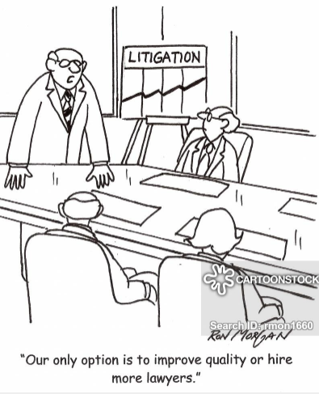

**THE MORGAN**

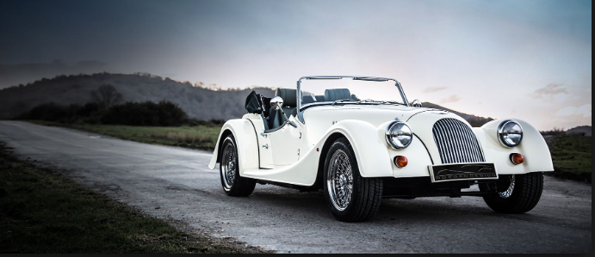

**Exercise 1.**

**Watch the video and answer** Click [***here***](https://drive.google.com/file/d/1iSU8WKoQY0R2pFqQZ2HEzznmvWQpLgv2/view?usp=sharing)

1. What sort of cars did the factory make at the beginning? They made 3-wheel cars.
2. Why are four-fours called so? Because they have 4 wheels and 4-cylinder engines.
3. What is the factory weekly output? It is about 11 cars per week.
4. Do they make the engines? No, they don’t. Other companies supply them.
5. What is the meaning of “built to order”? It means that each car is made after a client orders it.
6. What is Morgan’s best knwon car? It is the Roadster. -> el correcaminos.
7. What does the presenter say about the order books? She says that their order books are full.

**Choose the correct option**

1. Morgan first became famous because of its *car racing / modernity*

2. Morgan is different to other car companies because the cars are made by *machines / people*

3. Most of Morgan’s staff come from *all over the world / the surrounding area*

4. The customer orders a car *after / before* it is made

5. The company is most widely recognized for the *Aero 8 / Roadster*

6. It’s rare to find *person-made / hand-made* cars- they are usually made by machines

7. The process in other companies is completely *automated / machined*

8. All of our cars are built to *demand/ order*

9. Our *output / process* is low – only 50 cars a month – but the quality is exceptional.

10. We *put / place* them together once we have received an order.